Advanced Data Analysis and Visualization in Logistics
Week 3 Task — Exploratory Analysis and Visualization Report

Prepared by: Yash Kulkarni
Dataset Used: DataCo Smart Supply Chain Dataset

- Data Simulation and Dataset Structure –
For this task, the same DataCo Smart Supply Chain Dataset used in previous weeks (180,519 cleaned records) was analyzed further, with a focus on variables most relevant to logistics performance visualization: delivery timing (Days for shipping (real), Days for shipment (scheduled), Late_delivery_risk), shipment volume and value (Order Item Total, Sales per customer), transportation-related factors (Shipping Mode), and regional/geographic variables (Market, Order Region, Customer Country). These variables were selected because they directly relate to the KPIs defined in the earlier strategic plan on-time delivery, cycle time, and cost and because visualizing them can reveal patterns that raw numbers alone do not show, such as which shipping modes or scheduling patterns are driving delays.

- Data Cleaning and Preprocessing

- Central Tendencies and Distributions –
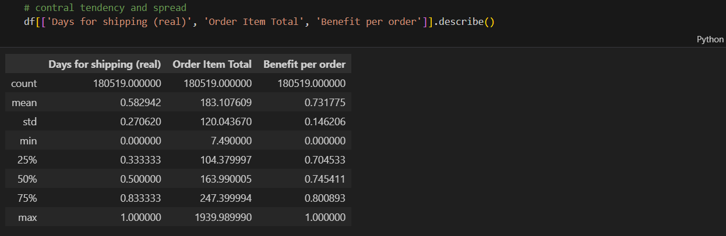
Central tendency analysis showed that the typical order value (Order Item Total) was $163.99 (median), with a mean of $183.11, indicating a right-skewed distribution where a smaller number of high-value orders pull the average upward. The previously normalized Days for shipping (real) and Benefit per order columns retained their 0–1 scale from Week 2's preprocessing, confirming consistency across the analysis pipeline.

      - Correlation Analysis –
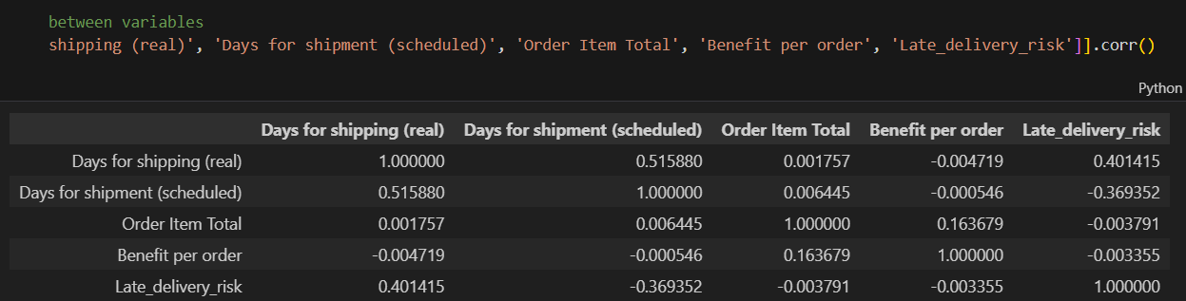
Correlation analysis was performed to identify relationships between key numeric variables. Real shipping days showed a moderate positive correlation with late delivery risk (0.4), while scheduled shipping days showed a moderate negative correlation with late delivery risk (-0.37) indicating that a longer promised delivery window reduces the likelihood of an order being flagged as at risk. A moderate positive correlation (0.52) was also found between real and scheduled shipping days, confirming a logical relationship between planned and actual delivery duration. Order value and profit variables showed very weak correlations with delivery timing (below 0.17), suggesting that delivery delays are not concentrated in any particular order value range.

- Visualizations –

      - Delivery Time Distribution (Histogram) –
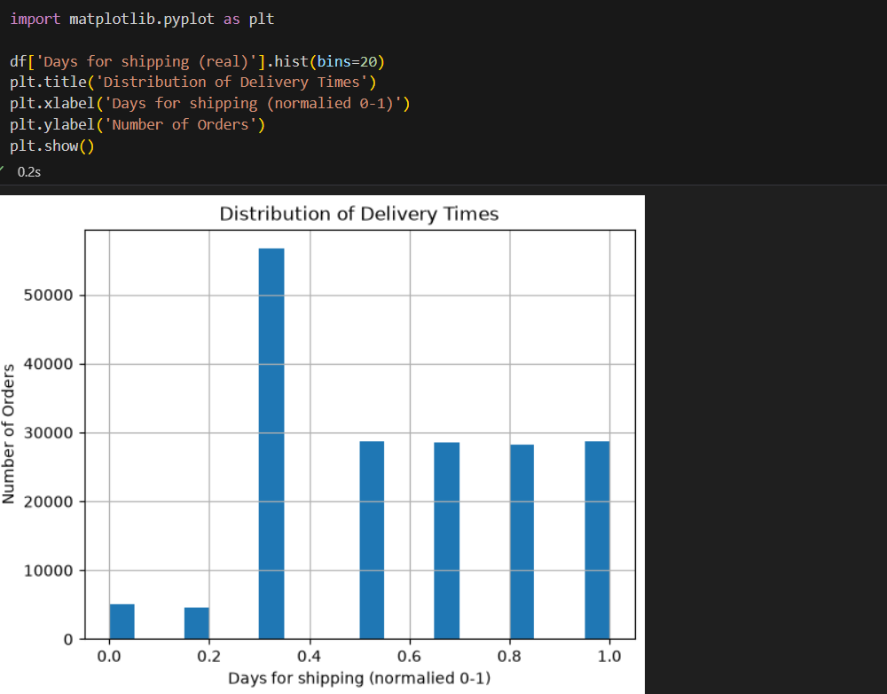
A histogram was used to visualize the distribution of Days for shipping (real), as this variable is continuous and a histogram is the appropriate tool for showing how a numeric variable is spread across its range.

The histogram revealed that the majority of orders cluster around a normalized shipping duration of approximately 0.33, with over 55,000 orders falling in this range, suggesting a dominant standard shipping duration. Very few orders were shipped in the fastest time bracket, indicating that fast shipping is relatively rare across the dataset.

- Shipping Mode Comparison (Bar Chart) –
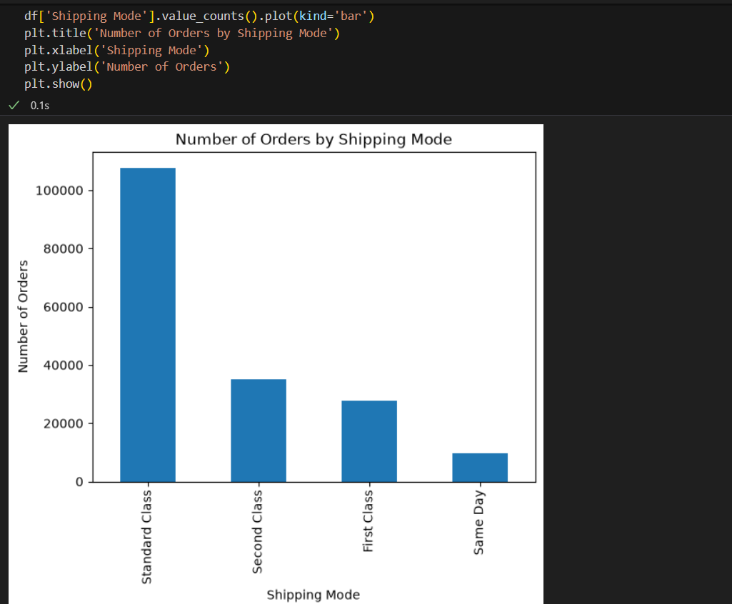
A bar chart was used to compare order counts across shipping modes, as this variable is categorical rather than continuous bar charts are the appropriate choice for comparing quantities across distinct categories.

      - The chart confirmed that Standard Class was overwhelmingly the most-used shipping mode, accounting for nearly 60% of all orders, while Same Day shipping was used far less frequently. This heavy reliance on the slowest shipping option offers a visual explanation for the delivery time clustering observed in the histogram.

      - Correlation Heatmap –
A correlation heatmap was used to visualize relationships between key numeric variables, as it allows patterns across multiple variable pairs to be spotted at a glance through color intensity, which is harder to do when scanning a table of numbers alone.
import seaborn as sns
corr_data = df[['Days for shipping (real)','Days for shipment (scheduled)','Order Item Total','Benefit per order','Late_delivery_risk']].corr()
sns.heatmap(corr_data, annot=True, cmap='coolwarm')
plt.title('Correlation Heatamap of Key Variables')
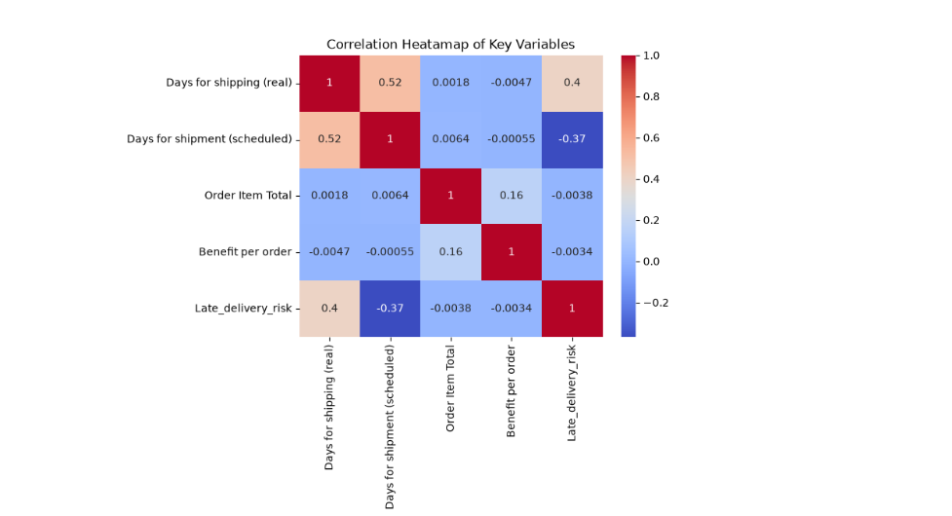
plt.show()

The heatmap revealed that real shipping days had a moderate positive correlation with late delivery risk (0.4), meaning orders that took longer to ship were more likely to be flagged as at risk of lateness. Conversely, scheduled shipping days showed a moderate negative correlation with late delivery risk (-0.37), suggesting that a longer promised delivery window reduces the likelihood of an order being marked as at risk. Order value and profit variables showed very weak correlations with delivery timing, indicating that delivery performance issues are not concentrated among specific order value ranges.

- Analytical Insights –

The exploratory analysis and visualizations produced several insights relevant to SwiftCart's operational efficiency and the bottlenecks identified in the original scenario.

- Delivery timing bottleneck: The histogram of delivery times revealed that a large cluster of orders (over 55,000) follow a single dominant shipping duration, while very few orders are shipped quickly. Combined with the bar chart showing that nearly 60% of orders use the slowest available option (Standard Class), this suggests that SwiftCart's default shipping policy rather than isolated failures is a primary driver of its delivery time challenges. This points to an operational lever leadership can act on directly: shifting a portion of Standard Class volume toward faster shipping modes could meaningfully reduce average delivery times.

- Late delivery risk is driven by shipping duration, not order value: The correlation heatmap showed that late delivery risk is moderately linked to both real shipping duration (0.4) and scheduled shipping duration (-0.37), confirming that how long an order is scheduled and how long it actually takes are the main forces behind lateness. Critically, order value and profitability showed almost no relationship with delivery risk, meaning late deliveries are not concentrated in cheap or expensive orders. This is an important operational insight: fixing delivery reliability requires broad process changes rather than a targeted fix aimed only at high-value shipments.

- Cost driver consideration: While this dataset does not include a direct delivery-cost field, the heavy reliance on Standard Class shipping the cheapest but slowest option suggests a trade-off SwiftCart is currently making between cost and speed. The data suggests this trade-off may be miscalibrated during peak periods, where the cost of lost sales from late deliveries could outweigh the shipping cost savings of defaulting to Standard Class.
Together, these insights suggest that SwiftCart's delivery performance problems are structural tied to shipping mode policy and scheduling buffers rather than isolated incidents, reinforcing the value of the regression and optimization techniques proposed in the Week 1 strategic plan, particularly route and shipping-mode optimization, which could directly target the pattern identified here.

